DT Level 1 Course Outline 2 – Animation

Guide to aid teacher planning - designed to be printed or viewed in A3, landscape.

Purpose
This example Course Outline has been produced to help teachers and schools understand the new NCEA Learning and Assessment matrices and could be used to create a year-long programme of learning. It will give teachers ideas of how the new standards might work to assess the curriculum at a particular level.

Significant Learning | Learning activities and assessment opportunities  Assessment for learning happens often throughout the year. Evidence may also be collected for summative assessment. | Duration  Total of 32 weeks.
understand the nature of computation and apply appropriate reasoning about the behaviour of basic programs  apply basic computational thinking skills (decomposition, abstraction, pattern recognition, algorithms, logic, and evaluation) to write and debug computer programs  determine the cost (or computational complexity) of two iterative algorithms for the same problem size  demonstrate learner agency and persevere when things fail  anticipate and find solutions to problems | Game Programming  Through a range of learning activities, learners learn about:  - input and output  - constants, variables, and data types  - conditional statements  - Boolean logic  - loops  - collections.  Class activities designed to help learners learn to decompose problems into discrete parts, and to design algorithms using different methods of representation such as flowcharts or pseudocode.  Explore what makes a good game (rules, challenging, difficulty levels, mastery, a story).  Class activities to help learners design and develop a series of increasingly complex games. They document their code with comments, follow programming ‘best practice’ which may be specific to their chosen language.  Activities designed to help learners follow an organised testing process and document that they have tested their program works on a range of inputs and conditions relevant to their program.  The summative assessment task will ask learners to independently develop a game. Use a Wall ‘o Games to generate unique and creative game ideas!  Work produced as part of this project may contribute to formative and summative assessment of AS92004 Create a computer program using Assessment Activity 1.1c Game to explain. | 10 weeks
prioritise user experience in design – practise manaakitanga by applying relevant design principles, mātāpono Māori, and usability principles  understand that digital technologies, and the concepts that underpin them, are influenced by the people that create them and the contexts in which they are developed  understand that digital technologies, and the concepts that underpin them, impact on people, societies, and cultures | Usability  To focus the learning, this unit will explore the user interface of some common smartphone apps.  Explore elements of usability such as consistency, human response time, short term memory, spatial memory, and patience.  Explore usability heuristics, using Jakob Neilsen’s “10 Usability Heuristics for User Interface Design”. Identify some positive and negative examples of the heuristics in selected smartphone apps.  In order to evaluate usability of an interface, it is useful to identify or design tasks for a user to attempt. Explore tasks that might help to identify usability issues in selected smartphone apps.  Carry out user tests using chosen tasks to identify usability issues in multiple interfaces using the think-aloud protocol. Classify usability issues against Neilsen’s heuristics. Use the results of the user tests to evaluate and suggest improvements to the given interface by comparing and contrasting the evaluated interfaces.  CAA preparation.  - Prepare for the CAA by answering a range of set questions under increasingly test-like conditions.  - Prepare material such as screenshots of a chosen interface to take into the CAA.  Learning covered/work produced during this unit will be assessed as Common Assessment Activity against AS92006 Demonstrate understanding of interface usability. | 6 weeks
follow a technological process or tikanga to design, develop, and document digital outcomes  use appropriate standards and conventions for digital technologies domains  apply appropriate tools and use information from testing to improve the quality of digital technologies outcomes | Intro to animation  Overview and history of animation.  Review examples of animation in the world around us.  Relevant context - comparing Toby Morris’ Covid animations with government Covid animated messages.  Students will learn basic techniques in animation:  - Drawing (brushes, stroke weight, smoothing, colour).  - Shapes.  - Layers.  - Text.  - Transformation.  - Keyframes, motion, and shape tweens.  Learners will be given a series of increasingly complex animations to recreate - each one introducing a new basic technique from the list above.  Class exercises give students an opportunity to practice skills and provide an opportunity for formative feedback. | 4 weeks
understand that digital technologies, and the concepts that underpin them, are influenced by the people that create them and the contexts in which they are developed  follow a technological process or tikanga to design, develop, and document digital outcomes  work collaboratively and engage in talanoa, korero, and wānanga to share perspectives and values  recognise that through kotahitanga and creative and critical thinking they can develop new and innovative solutions to existing problems | 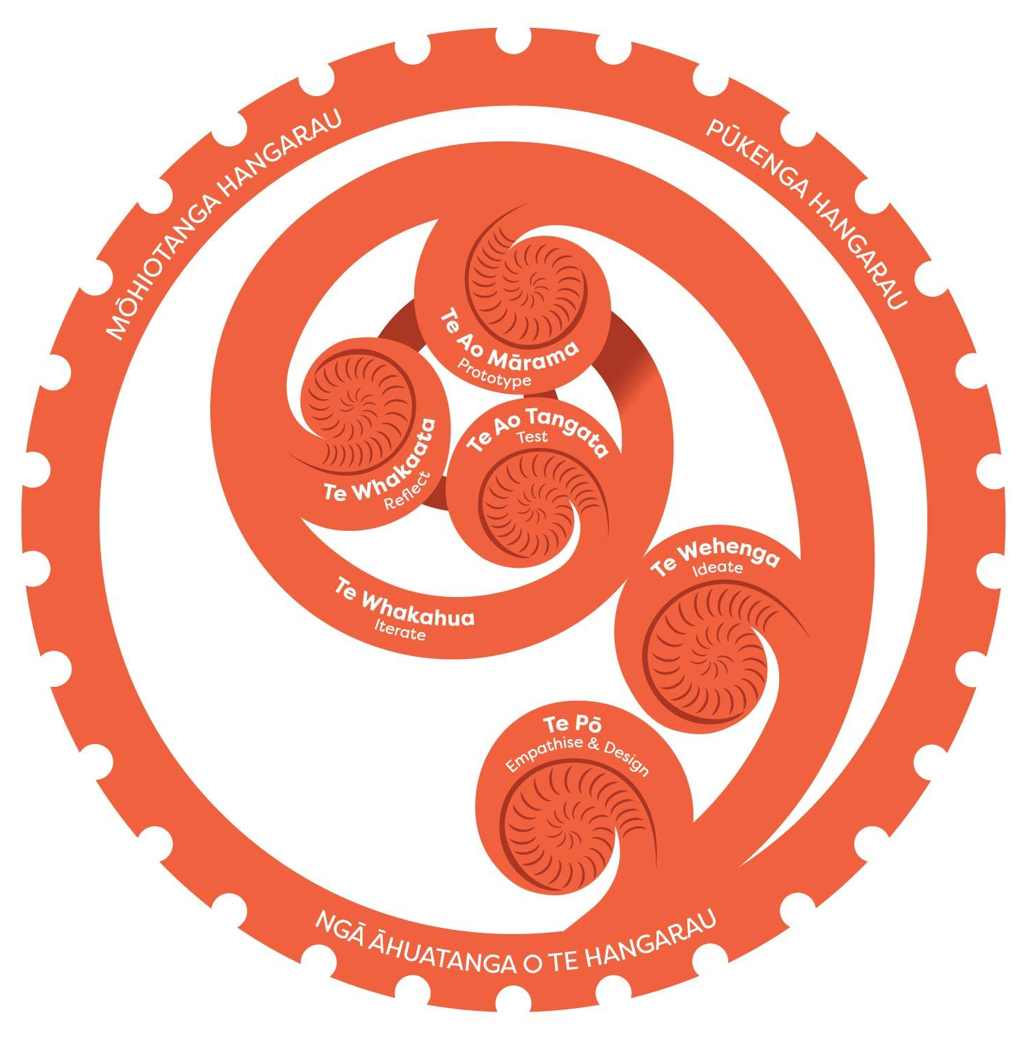  Introduce Te Tukanga Hoahoa Whakaaro.  Learn a design thinking process to apply in this year’s projects.  Te tukanga hoahoa whakaaro  Overview of te tukanga hoahoa whakairo in te reo  The creation story - Ranginui and Papatūānuku  6 stages in the process  - Te Pō | Empathise & Define  - Te Wehenga | Ideate  - Te Ao Mārama | Prototype  - Te Whakaata | Reflect  - Te Ao Tangata | Test  - Te Whakaahua | Iterate  Overview of a range of design processes  Activities to develop understanding may include:  - creating a storyboard for the creation story  - briefly look at creation stories from other cultures to look for similarities to the design process (Samoan Tagaloa or Tongan Talatupu’a – this may depend on the cultural make-up of the class)  Te tukanga hoahoa whakaaro. This image was developed under the Ministry of Education funded programme, Kia Takatū ā-Matihiko  CC BY-ND 4.0 Creative Commons license  - learners designing their own model for this process - could be similar to original or more linear with cycles  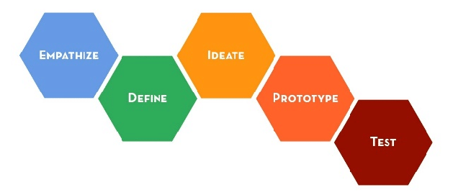  - comparison with a common design thinking process such as the Stanford D.school process  - exploration of other design processes to find similarities and differences (cyclical vs linear, for example) in order to understand that there is no ‘one’ design thinking process.  Stanford d.school design thinking process. By Stanford d.school  CC BY-ND 4.0 Creative Commons license | 1 week
investigate and consider possible digital solutions for authentic contexts or issues  follow a technological process or tikanga to design, develop and document digital outcomes  prioritise user experience in design – practise manaakitanga by applying relevant design principles, mātāpono Māori, and usability principles  apply appropriate tools and use information from testing to improve the quality of digital technologies outcomes  learn to be respectful and open-minded whilst considering the cultural safety of themselves and others  recognise that through kotahitanga, and creative and critical thinking they can develop new and innovative solutions to existing problems  understand how digital technologies impact on end users by considering the following mātāpono Māori:  kotahitanga, whanaungatanga, manaakitanga, wairuatanga, kaitiakitanga, and tikanga  anticipate and find solutions to problems | Animation design  Reinforce the idea of animation as a tool to communicate a message.  Exploration of manaakitanga and kaitiakitanga as lenses that can be used when thinking about creating something for people to use.  Overview of the Technological design process (scoping a project, relevant implications, designing and refining ideas, communication and evaluation of design).  Exploration of design tools (story boards, etc).  Te Pō  Identify and research a group or club within the school who could benefit from an animation, develop a short proposal.  - Brainstorm groups/clubs.  - Research the chosen club, their needs (for wanting the animation).  - Consider how the design will impact manaakitanga and kaitiakitanga.  - Using a template, students identify the need or opportunity, potential users of the animation, and basic requirements of the animation.  Te Wehenga | Te Ao Mārama  Design ideas  - Generate a wide range of concepts. These might include elements of the overall animation design such as storyboards and character sketches.  - Use research into the chosen group to inform concepts.  - Use feedback to select a concept to develop.  Te Whakaata | Te Ao Tangata | Te Whakaahua  Develop design through reflecting on te ao Māori concepts, integrating evidence from testing ideas (possibly through prototyping).  - Describe how manaakitanga or kaitiakitanga are reflected in the designs.  - Develop the concept using feedback and user perspectives.  - Apply design principles to improve the design.  Final design  - Explain/justify that the proposed outcome addresses the purpose and meets the requirements of the club/group (fitness for purpose).  - Explain how te ao Māori concepts (manākitanga, kaitiakitanga) contribute to fitness for purpose.  Work produced as part of this project to contribute to the formative and summative assessment of AS92007 Design a Digital Technologies Outcome | 4 weeks
follow a technological process or tikanga to design, develop and document digital outcomes  use appropriate standards and conventions for digital technologies domains  apply appropriate tools and use information from testing to improve the quality of digital technologies outcomes  understand that digital devices can collect, store, and share data, and the ethical issues related to this  work collaboratively and engage in talanoa, korero, and wānanga to share perspectives and values  use appropriate strategies to manage their time and resources for completing a project  evaluate the fitness for purpose of digital technologies outcomes by considering manaakitanga, kaitiakitanga, and the outcomes’ social and physical environments | Animation development  Building on the learning earlier in the year, students will follow a technological process to develop an animation.  Class exercises teach students about managing timeframes and about effective feedback and testing strategies.  Based on their design, learners will now develop the animation they have designed. They might:  - identify purpose, specifications, and user requirements for the animation  - break the animation into components and use an iterative process to develop their animation  - use a range of basic animation techniques in appropriate software  - consider usability and design principles in their development  - consider te ao Māori concepts when developing their animation  - test their animation with end users and use feedback to improve their animation and to ensure fitness for purpose against the original specifications and user requirements  - export their completed animation using appropriate parameters for file type, compression, etc.  Work produced as part of this project will contribute to formative and summative assessment of AS92005 Develop a digital technologies outcome with Assessment Activity 1.2a Kōrero Paki. | 6 weeks
investigate and consider possible digital solutions for authentic contexts or issues  follow a technological process or tikanga to design, develop, and document digital outcomes  understand that digital technologies, and the concepts that underpin them, are influenced by the people that create them and the contexts in which they are developed  prioritise user experience in design – practise manaakitanga by applying relevant design principles, mātāpono Māori, and usability principles | Portfolio prep  Learners will select work from their design portfolio to present in a format satisfying the assessment specification and instructions. If it helps to support their design work they could also draw on evidence generated in the development of the animation.  Explore communication methods such as layout, annotation, and application of design elements to enhance student submissions.  This portfolio will be submitted to NZQA and assessed against AS92007 Design a Digital Technologies Outcome. | 2 weeks

