Review of Achievement Standards Level 1, Phase 1
Feedback Report Materials and Processing Technology
Feedback provided on draft, Phase 1 products as at 19 April 2021

Contents
Purpose 1
Background 1
General Overview and Themes 2
Sources of Feedback 4
Next Steps 6

Purpose
This report outlines the feedback received by the Ministry of Education (the Ministry) on the Phase 1 development of Level 1 subject content for Materials and Processing Technology. It aims to identify common themes and trends across the feedback. This report will be used to inform any necessary changes to the products developed so far as well as the further development of Phase 2 subject content by the Subject Expert Groups (SEGs) as part of the Review of Achievement Standards (RAS).

Background

- The Ministry received 111 responses to the Ministry’s online survey about the subject content developed so far for Materials and Processing Technology. These included both multiple choice answer questions and long form, written response questions.
- The Ministry also conducted Focus Group meetings with members of the education sector who provided feedback on the draft subject content.
- Feedback was also provided by the four NCEA panels. Each panel did not review every subject or product - for Materials and Processing Technology, feedback was received from the Disability and Learning Support NCEA Panel, but there was general feedback from the other panels that is relevant to the subject and as such has been included in this report.
- This report is divided into the following:
  - General Overview and Themes
  - Analysis of Feedback by Source
    - Online
    - Focus Group
    - NCEA Panels
  - Next steps
- Please note that the content in this report does not reflect the opinions of the authors. The report aims to thoroughly and accurately reflect the views presented by those who fed back on the draft subject content.

General Overview and Themes

- Options for students who take more than one Materials and Processing Technology subject
One of the strongest themes in the feedback was concern for students who wanted to take more than one of the pre-existing subjects (such as textiles, food technology, hard materials, and so on) which have now been combined to create Materials and Processing Technology. A number of comments suggest that there are quite a large number of students who prefer to take several ‘hands on’ technology and materials subjects in NCEA Level 1: some indicate a belief that these students do not always achieve success in other, less hands-on subjects. The respondents fear that these students will be disadvantaged as they will only be able to sit Achievement Standards for one subject – possibly rendering them unable to gain enough credits to pass NCEA Level 1, if they take more than 1 Materials and Processing Technology subject. This would then affect pathways for these students. These fears are expressed in the following quote, which is typical:
“Many students need to take more then (sic) one material technology subject and they are creatively inclined. Often these are the only subjects they are successful in.”
Furthermore, survey respondents felt this consolidation would have the unintended consequence of creating timetabling issues in schools and cause a possible reduction in the number of specialist teachers, further reducing student choice.
This concern was also expressed by the Materials and Processing Technology focus group.

- Concerns over possible loss of practical skills
Related to the theme above were concerns about the acquisition of physical technology skills in NCEA Level 1. This concern was noted in both the focus group and the survey responses. The following comments from the survey are typical of this concern:
“Because we are becoming increasingly digital in our experiencing of the world at an earlier and earlier age, many of our younger people are losing their physical (or concrete) connection to the world. We are no longer able to tinker with things, and are losing the intuitive sense of how things are put together or even stand up.”
”It seems to me that the practical components of technology is (sic) not at the centre of the subject.”
Survey respondents indicated a belief that the Significant Learning in the Learning Matrix was focused on abstract ideas rather than practical skills. As with the theme above, many commentators were concerned about the effect a skill deficit could have on student pathways. Some respondents assumed that, due to the consolidated nature of this subject and possible unintended consequences of the same, students would not be able to study several Materials and Processing Technology disciplines at NCEA Level 1, and this would curtail study choice in NCEA Levels 2 and 3 and beyond. Some comments suggested that schools might instead choose to abandon NCEA Achievement Standards for these subjects and use Unit Standards or courses offered by other providers (such as the Building and Construction Industry Training Organisation (BCITO)) instead – a choice which was viewed negatively by those who suggested it.
This theme is linked to concerns about external and written assessment (see below). It also aligns with survey comments from respondents who felt that students were coming to technology subjects with unequal prior experiences and skills, disadvantaging some.

- The inclusion of mātauranga Māori in the draft Phase 1 subject content
Both focus group and survey feedback acknowledged the importance of the inclusion of mātauranga Māori in the draft Phase 1 subject content for Materials and Processing Technology, and there were positive, supportive comments from both groups. However, both survey respondents and the focus group were concerned about the low level of teacher capability in this space and suggested extensive professional development and support would be required. As part of the survey feedback, a number of commentators expressed concerns that Māori teachers would be expected to support their non-Māori colleagues to develop these skills, as expressed in the following quote:
“This will have to be supported with robust resources and professional learning and may put stress on a limited number of experts nationwide (…) I am concerned that Māori teachers within schools will be burdened with delivering professional learning to meet the needs of the whole school”
A few survey respondents were concerned that some Māori practices might exclude some students from some contexts and activities due to traditional gender practices: others commented that differing practices across iwi and rohe, and the variable availability of traditional materials, would mean that student access to related skills, experts, and knowledge could be uneven on a national level.

- Concerns regarding external and written assessment
Most of the survey respondents who commented on the proposed AS 1.3 (Select materials and apply skills to make a fit-for-purpose product for an authentic context) felt this assessment should not be externally assessed. These commentators believed the proposed assessment would need to be a written assessment instead of one where a student would create a physical outcome or product. A general preference for practical, physical outcomes and skill practice instead of written evidence of learning was a common theme in the survey feedback. This comment regarding AS 1.3 is indicative of this concern:
“…as 1.3 is an external and NZQA stopped assessor visitation to schools years ago, I can only assume a written portfolio will be the submission. We have to consider the students who prefer to express themselves in a tactile manner and who still deserve access to Merit & Excellence.”
This theme was linked to concerns regarding the potential loss of practical skills in NCEA Level 1 teaching and practice (see above). Concerns about external assessment were also expressed in the focus group, who also showed strong opposition to written assessments for this subject.

- General comments from the online survey
A minor theme from the survey responses suggested that the concept of wellbeing arising from crafting/creating a physical outcome from tangible components was integral to Materials and Processing Technology and could be incorporated in the draft subject content, as expressed below:
“This misses the opportunity to consider hauora, including emotional and spiritual needs, making for well-being”
“(W)here in the Learning Matrix is the opportunity to create and make products for the intrinsic joy of making something beautiful and functional? Where is the acknowledgement that materials and processing technologies can be used to create something whose main function is the well-being it engenders through the act of making (?)”
Other respondents expressed concern regarding the less tangible skills included in the Teaching, Learning and Assessment Guide (TLAG). Some comments expressed concern that the content was ‘too vague’ and difficult to quantify.
”How are the soft skills measured? (…) These are not learning outcomes and should not be in this column.”
Respondents questioned how electronics could be taught with the proposed subject materials.
And finally, sustainability and health and safety were also seen to be important to the study of Materials and Processing Technology.

Sources of Feedback

Online
Below are the quantitative data questions summarised in graphs.
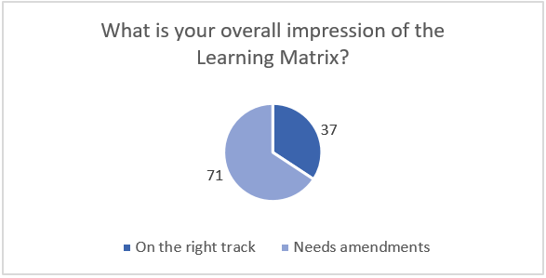
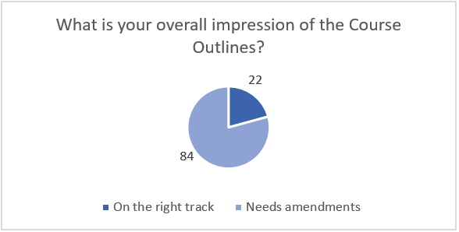
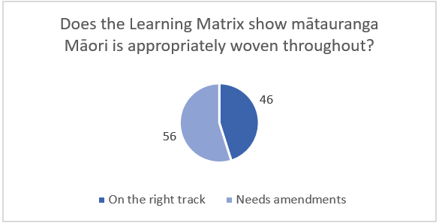
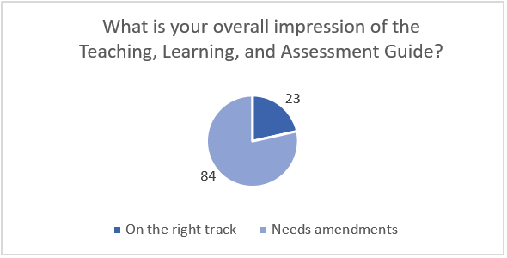

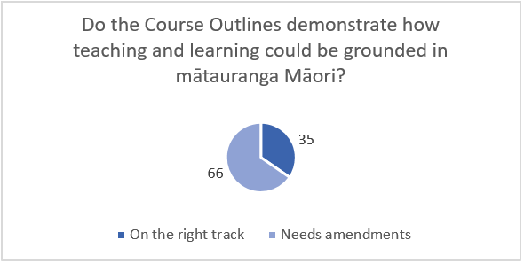
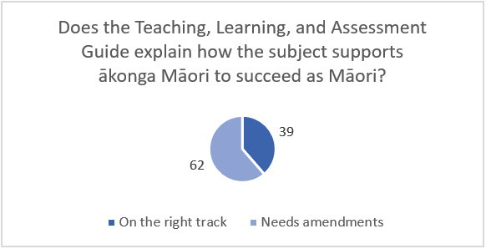

In general, the quantitative data suggests that respondents are divided in their opinions of the proposed draft Phase 1 subject content for Materials and Processing Technology.

Focus Group
The focus group consisted of 13 participants, external of Ministry officials. Three attendees were heads of departments and one was the president of a related teachers association. The meeting and discussion were led by one of the Materials and Processing Technology Critical Friends.
The feedback from the focus group session was largely positive; however, concerns were raised about the possibility of learners having to ‘choose’ between a Māori or Pacific context. It was felt that the draft phase 1 subject content had “made a good start” in terms of incorporating mātauranga Māori but it could be strengthened. There was acknowledgement that this would be a significant shift for some teachers and schools and would require support and professional development. A suggestion was made that supporting documents could be developed, to show how technology teachers could incorporate mātauranga Māori into their teaching. The group also wanted to see more Pacific knowledge and context referenced within the new assessments and Learning Matrix.
Several focus group participants commented on the need for consistent language across all the NCEA level 1 technology subjects (Materials and Processing Technology, Digital Technologies, and Design and Visual Communication). A comment was made that the words ‘worldview, local view, and practice’ were key words for technology subjects. There was discussion regarding the words ‘outcome’ and ‘product’: it was noted that the New Zealand Curriculum used the word ‘outcome’.
There was discussion around the collecting of evidence for assessment, particularly for externally-assessed standards. While there were concerns raised around digital literacy and safety when collecting visual evidence, there was also acknowledgement that allowing students to explore this space enabled collaboration and peer critique, as well as the development of digital skills.
Some of the focus group feedback echoed themes from the survey responses. For example, although the group accepted the consolidated nature of the subject, there were concerns raised about students who would want to study different disciplines within Materials and Processing Technology, as they would not be able to sit the same Achievement Standards for different disciplines. The tension between ‘doing’ and thinking about why and how things are done was also discussed; fears were expressed that some discipline-specific skills would be lost. (Note: this was also strongly expressed in the responses to the online survey.)

In terms of assessment, a comment was made that Unit Standards are industry-focused whereas the proposed Achievement Standards were locally focused. This was not seen as a problem, but it was noted that some teachers might find it difficult to shift from more rigid assessment . However, there was still uncertainty around how the external assessments could be designed and marked. There was strong opposition to having students write reports as part of the Achievement Standards. The group was happy to see sustainability addressed in AS1.1 (Propose, plan and model the development of a materials or processing technology product considering sustainable use of resources): There were concerns. However, that the work required was worth much more than 5 credits. They also felt the concept of safety was critical, and wanted to include it in an Achievement Standard.
Finally, the focus group debated new names for the subject. The most popular was ‘Product Design Technologies’; other options raised were ‘Product and Design Technologies’, and ‘Product Design Innovation’.

NCEA Panels
The NCEA Panels have raised some important issues which complement some of the themes arising from the online survey and Focus Group data.
The Māori Panel noted that the Materials and Processing Technology Big Ideas and Learning Matrix should be grounded in the technology learning area whakataukī. In general, the Māori Panel were concerned about the use of kupu – that they should not simply be included as replacements for Pākehā words - and concepts Māori, and whether these were being used authentically. This same concern was reflected in the survey feedback.
The Pacific Panel indicated that more support was required for the Pacific developers of the Phase 1 subject content. They were concerned that developed resources not be tokenistic or considered as an afterthought. There was also concern around the complexity of incorporating a range of Pacific contexts.
The Pathways Panel felt that there could be more clarification around the role of Materials and Processing Technology in supporting students to follow relevant pathways. They also acknowledged that this may be difficult for consolidated subjects such as this one.
The Disability and Learning Support Panel noted some instances where inclusive language could be added to the Materials and Processing Technology subject content, or existing terms could be altered to be more inclusive. One word in particular was the word ‘fail’, as included in the Big Ideas (“Because great problem solving and innovation is often achieved through failure, students should be encouraged to trial and take enough risks to fail , as well as to succeed, and to share their learning with others.”) It was noted that the words fail and failure could be emotionally loaded terms for some students. The panel also suggested replacing the term ‘sustainable practice’ with ‘inclusive practice’ in both the Big Ideas and Assessment Matrix. In general, questions were asked about the inclusion of discipline-specific terms within the Materials and Processing Technology phase 1 subject content, and whether these needed to be included. Examples given were ‘Gantt chart’ and ‘fit for purpose outcome’.
The Disability and Learning Support Panel echoed concerns raised by survey respondents concerning the grouping of subjects (for example, hard materials, food technology, and textiles) within the new Materials and Processing Technology subject. As with the survey feedback, the panel noted that this may disadvantage students who have technical skills but are challenged in other areas.
Finally, the panel noted that while health and safety was an important aspect for student learning in this subject it should not be a barrier for students with diverse learning needs.

Next Steps

There are several recommendations which will be undertaken prior to reengaging the SEG. Some are too specific to detail in this report, but the overall themes are:
Ministry Actions
- Ministry to clarify position on addressing PLD concerns relation to:
  - being able to adequately reflect and competently deliver Mātauranga Māori in classroom settings, especially understanding kupu and concepts Māori
  - preparing sample or exemplar materials to support the delivery of the new teaching, learning, and assessment materials.
- Ministry to consider and respond if required to concerns from the sector regarding NCEA options and pathways for students who study, or wish to study, more than one Materials and Processing Technology context at NCEA Level 1.
- Ministry to clarify whether the study of electronics/robotics in NCEA is a Materials and Processing Technology context, or if it belongs in another subject.
- Ministry to consider, along with the SEG, changing the name of the subject to ‘Product Design Technologies’.

SEG actions
- SEG to review, written content requirements for the proposed Achievement Standards, and make changes to the assessment formats, or the standards themselves, if required.
- SEG to incorporate feedback from the Māori and Pacific panels re to ensure more appro the subject content reflects, and can support, all learners.
- SEG to consider potential revisions to the Learning Matrix to include practical skills, where relevant and appropriate.
- SEG to consider, along with the Ministry, changing the name of the subject to ‘Product Design Technologies’.
- SEG to work through the feedback from the Disability and Learning Support Panel and make any applicable changes to the draft Phase 1 subject content, specifically regarding the word ‘fail’.
- SEG to clarify, alongside NZQA, the way/s in external assessment is to be carried out for Materials and Processing Technology.

