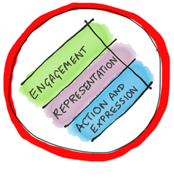
Identifying common barriers in your subject area?

A UDL approach intentionally anticipates, identifies and addresses barriers up
front to ensure learning environments are equitable and free from discrimination and bias.

Engagement  Supporting motivation, interest, identity and self regulation. |  | 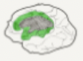
What barriers to engagement might ākonga experience in the design of my lesson?  - Interest in topic | Supports:  - Option for learners to identify own topic
Representation
Supporting access to information, creating flexible content and building understanding.
What barriers to accessing and understanding information might ākonga experience in the way I communicate and present information (instructions, content and materials)?  - Text heavy content | Supports:  - Model and offer text-to-speech options
Action and expression
Supporting access to learning materials, personal organisation, expressing thinking and learning.
What barriers to participating and demonstrating learning might ākonga experience in the design of my lesson?  - End of term quiz online | Supports:  - Incorporate a variety of assessment formats

