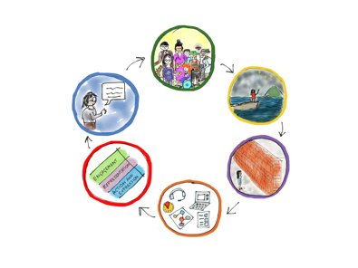
Design and review a course outline with a UDL lens
Purpose: Strengthen the equity and inclusion of a course outline and unit plans using the UDL thinking cycle.

 | Prompts for thinking and planning |  | Notes and ideas
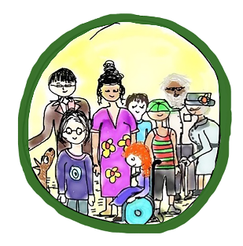 |  | What do we know about the ākonga who will participate in this learning?  - What do we know about our ākonga as a group?  - What do we know about specific ākonga?  - What do we know about prior learning and strengths in this area?  - What community connections and relationships do we have to this area of learning?  What do we know about when this learning will happen?
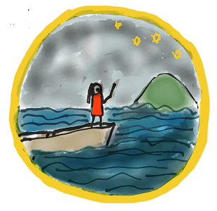 |  | What is the purpose and goal of this course outline/unit/chunk of learning?  - In what ways will this unit resonate and have value for ākonga?  - How can ākonga be involved in the design?
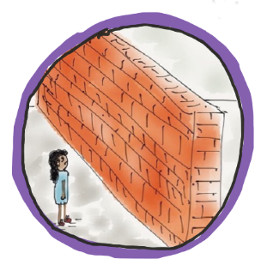 |  | What in our design or the way we teach and communicate could create inequity and discrimination or get in the way of learning?​  Think about possible barriers to:  - ​engagement and motivation  - accessing and understanding information ​  - participating in learning and expressing knowledge.
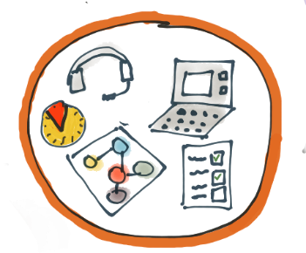 |  | What kinds of teaching approaches, resources, tools, experiences can we build into the learning environment and offer to everyone?  - What options could we include that ākonga have found useful in the past?  - What 1:1 or differentiated approaches could be embedded into the design and offered to everyone?
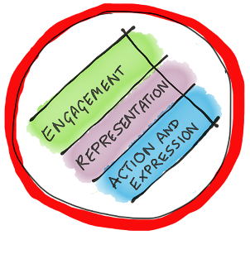 |  | Draw on your thinking above to create a draft proposal of everything you want to include in your course outline and/or unit plans.

 | Refining questions |  | Notes and ideas
Supporting engagement |  | How can we increase options and supports to:  - connect with the cultures, languages, identities, abilities, strengths, and interests of ākonga,  - ensure the design is actively inclusive of diverse perspectives and experiences and free from racism and discrimination  - give equal status to mātauranga Māori  - offer choice and support autonomy  - foster collaboration and community  - make connections to the world beyond school  - sustain motivation?  Are there any hidden barriers to engagement in our design?
Supporting access & understanding |  | What options could we build in to:  - ensure the materials or resources we offer are available in multiple media  - support understanding of new or important key concepts, symbols and vocabulary,  - support understanding across our different cultures and languages  - build on previous learning.
Supporting participation and expression |  | What options can we include to enable all ākonga to:  - access activities materials, tools and learning environments  - demonstrate understanding in multiple ways  - build their goal setting, planning and self-management skills?
Now you have a draft plan, consider the refining questions below. These are aligned to the 3 principles of Universal Design for Learning and will help you think critically about ways to strengthen the equity and inclusion of your design. You are welcome to add or tweak the questions for your context.

