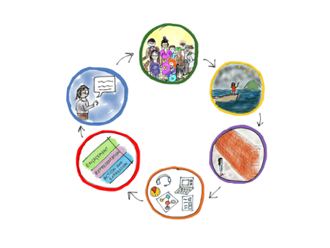

Planning an assessment with a UDL lens

Purpose: Universally design an activity guided by the UDL thinking cycle.

Instructions: Read and reflect on prompting questions. Expand each box to jot down responses.

 | UDL Reflection: prompting questions
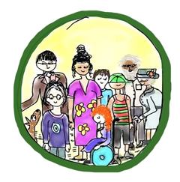  Who are the people and what do we know? | - Who are the ākonga and what do we know about their variability as a group?  - What information do I know about specific ākonga? (e.g. preferences, needs, experiences)  - What’s on top for ākonga that could have an impact on learning and wellbeing?  - What do I know about the context and setting (time of day, environment etc)?
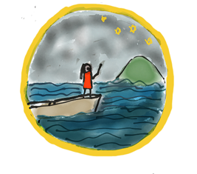  What is the purpose and goal? | - What is the purpose and goal of the activity?  - What will success look like?  - How will we share the purpose and goal of the activity?  - Can we create an opportunity where the goal/purpose is designed with ākonga?
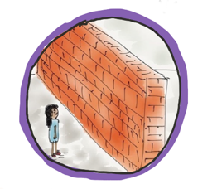  What barriers (in the way we do things) could get in the way for people? | What in our design or the way we teach and communicate could create inequity and discrimination or get in the way of learning?  - What could get in the way of the engagement and motivation of ākonga or create anxiety?  - What could create confusion or get in the way of people connecting to new ideas?  - What could stop ākonga fully participating, collaborating, and sharing their thinking?
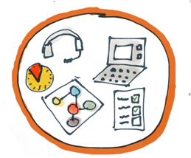  What can we build into the activity and offer to everyone? | - What kinds of approaches, tools and supports could we include and offer to everyone?  - What options could we include that ākonga have found helpful in the past?
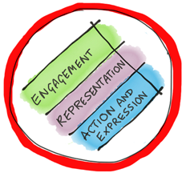Make a plan | Mock up a draft plan (expand this box as much as you need)  Then check and refine plan using the prompts in the three rows below.
Refine plan to increase support for engagement  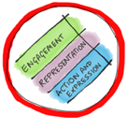 | What options and design decisions could we include to:  - connect with the culture, language, identity, strengths and interests of ākonga?  - reduce threats and distractions?  - support self-regulation?  What supports can we offer for working independently or in groups?
Refine plan to increase support for access & understanding | What options could we use to:  - support key concepts and new or important vocabulary?  - present the activity instructions in different ways?  - ensure everyone has access to materials and resources?
Refine plan to increase support for participation and expression | What options can we include to:  - help ākonga keep the goal in mind?  - enable everyone to participate in a way that works for them?  - support communication and expression of new learning?  - support personal organisation and time management?
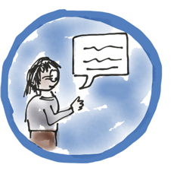  Implement, then review | How will we get feedback on this activity?  What options and tools could we offer for feedback knowing that one way won’t work for everyone, e.g. survey, poll, comment, text or email?

