Keyword Trees

Reading: US 32403 Demonstrate understanding of ideas and information in written texts
This activity supports learners to achieve Reading Outcome 1: Learners read to make sense of the written text.
Significant Learning:  Learners use vocabulary knowledge. Successful comprehension depends on understanding most of the meanings of the words in the text. | Purpose:  This helps students to understand keywords of a topic and identify relationships between them. They work best with hierarchical information.
Application:  At the beginning of a unit as a formative task or any time a teacher wants to assess the progress of vocabulary learning. | Source:  Effective Literacy Strategies in Years 9-13  p40 (Keyword Trees are also known as ‘Structured Overviews’)
Instructions:
- Select the keywords that relate to the one main idea and organize them into a structured overview. These are the answers; students are not shown this.
- Draw a blank version of the overview (The tree). In other words, draw the boxes and lines and arrows but add no words. Create a separate list of the words.
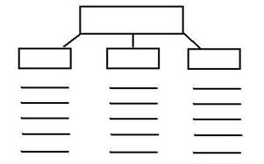

- Give the students the tree and the list of words. Model the correct place of two or three words, explaining why and then ask them to complete the task.
- Once students have had a chance to work alone, set up pairs or small groups to discuss their answers, changing any options they feel are better as they go.

